Module One Assignment1: Data Modeling
Data modelling is an important step in database design because it helps organize data in a structured way so it can be stored, updated, and analysed efficiently. In this assignment, the two provided USDA nutrition data sets are combined: the Nutritional Descriptions table and the Nutritional Values table. The first file explains each nutrient, while the second file stores nutrient values for different food items.
1. Compare Various Data Modeling Techniques
a) Relational Data Model
The relational model stores data in tables made of rows and columns. Each table has a primary key, and relationships between tables are created using foreign keys. In this case, one table would store nutrient descriptions and another table would store nutrient values. The nutrient code would connect both tables. This model is very effective for structured data because it reduces duplication and keeps data accurate. It also allows easy searching with SQL queries. It can scale well when indexes and normalization are used, although very large systems may need optimization (Elmasri & Navathe, 2016).
b) Hierarchical Data Model
The hierarchical model stores data in a tree structure where each child has one parent. If used here, a food item could be the parent and nutrients could be child records. This model can be fast for simple parent-child relationships, but it is less flexible because many-to-many relationships are difficult to manage. If new nutrient categories are added later, redesign may be needed.
c) Document Model
A document model/No-SQL stores data in JSON-like documents. Each food item could contain all nutrient values inside one record. This model is scalable and useful for large systems with changing structures. However, it may create repeated nutrient description data and can reduce consistency compared to relational databases (Sadalage & Fowler, 2013).
Comparison
Model | Scalability | Efficiency | Accuracy
Relational | High | High for structured queries | Very high
Hierarchical | Medium | Fast for tree data | Medium
NoSQL Document | Very High | High for flexible storage | Medium

Impact of Data Set Contents
The provided data sets are highly structured and contain repeated nutrient codes. Because of this, the relational model is the best choice. Nutrient descriptions are separate from nutrient values, which naturally support table relationships.
2. Selected Modeling Approach
The most appropriate modeling approach for the combined data sets is the Relational Data Model.
3. Justification of Selected Approach:
The relational model best supports the structure of the data because the two files already behave like related tables.
- The Nutrient Descriptions file stores details about each nutrient code.
- The Nutrient Values file stores measurements for foods using the same nutrient code.
By using a relational design:
- Data duplication is reduced.
- Nutrient descriptions are stored once.
- Data integrity can be enforced using primary and foreign keys.
4. Entity Relationship Diagram (ERD)
a) Entities and Attributes
Entity 1: NutrientDescriptions
- NutrientCode (PK)
- NutrientDescription
- NutrientAbbrev
- NutrientUnit
- DateAdded
- LastModified
Entity 2: NutrientValues
- ValueID (PK)
- CnCode
- NutrientCode (FK)
- NutrientValue
- PerUnit
- ValueTypeCode
- SourceCode
- DateAdded
- LastModified

b) Relationship
- One nutrient description can have many nutrient values.
- NutrientDescriptions.NutrientCode = NutrientValues.NutrientCode
ERD Diagram
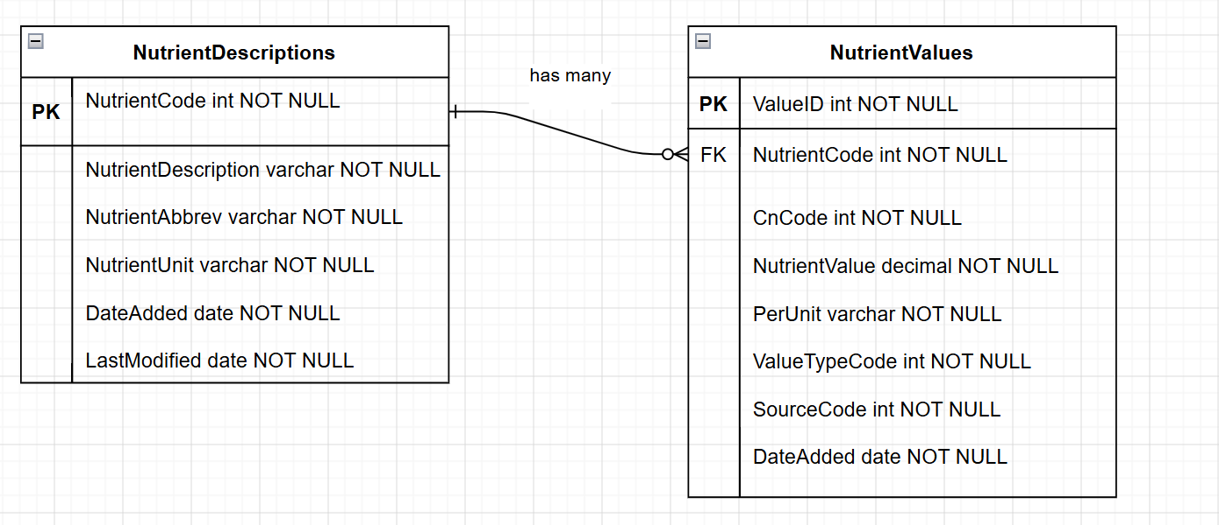
5. Scalability and Flexibility of the ERD
This ERD supports scalability because new foods and nutrient values can be added without changing the nutrient description table. If USDA adds new nutrients such as minerals or vitamins, only one new record is needed in the NutrientDescriptions table.
The design is also flexible because:
- Additional food tables can be connected later using CnCode.
- New measurement units can be added.
- Queries remain efficient with indexing.
- Maintenance becomes easier because duplicate data is minimized.
This normalized design is suitable for future growth and large nutrition databases.
After comparing different data modeling techniques, the relational model is the best choice for these USDA nutrition data sets. The data is structured, uses shared nutrient codes, and needs high accuracy. The ERD created with two linked entities provides a clean and scalable solution. This design will support future database growth while maintaining data consistency and efficiency.
References
Coronel, C., & Morris, S. (2019). Database systems: Design, implementation, & management (13th ed.). Cengage Learning.
Elmasri, R., & Navathe, S. B. (2016). Fundamentals of database systems (7th ed.). Pearson.
Sadalage, P. J., & Fowler, M. (2013). NoSQL distilled: A brief guide to the emerging world of polyglot persistence. Addison-Wesley.

